Possible Adoptees 7/11

* Information about the Breeds I am interested in (and for which I have found available, adoptable, “local” kittens)
  + **Overview of the Exotic Shorthair:**
    - Originated from Australia
    - For those who adore the good looks of the Persian, but haven't the time the grooming, then the 'shorthaired Persian' is just the cat for you. Like the Persian, they have: big round eyes, small ears, flat face with short snub nose, sweet facial expression, sturdy build, cobby body and short little legs (like a cuddly teddy), quiet voice, placid demeanor, and gentle non-intrusive mannerisms. Everything but the labor-intensive long coat.
    - Temperament: Blessed with a laid-back, happy-go-lucky nature and unruffled manner that takes everything in stride, it is a practical cat choice for those with busy lifestyles. Although it cherishes close interaction with people, this undemanding no-fuss feline is content in its own company or that of other household pets. This highly adaptable breed readily fits in to any situation and makes a charming all-round family pet.
    - Coat: Known as the 'wash-and-wear Persian', the Exotic Shorthair has a luxurious low maintenance plush velvet jacket, which comes in a kaleidoscope of beautiful colors and patterns.
  + **Overview of Russian Blue:**
    - Also an Australian import (and now comes in Black and…)
    - The Russian Blue, with its vivid green eyes, long thin body and distinctive double coat, is one of the most coveted of the short-haired cats. A good Russian Blue should have large, thinly-furred ears, small oval feet, slender legs and a narrow tail.
    - Temperament**:** As a companion, this breed has much to recommend it. A cat with a strong personality, they insist upon taking an active part in their owner’s lives, with whom they bond very closely.
    - Coat: It is believed their seal-like coats were their natural protection against the very cold Russian climate, from which they originated. The distinctive coat is a lustrous, even coloured blue with silver tipped guard hairs, and patting them has been described as feeling like running a silk scarf through your hands. One of the special features of the Russian Blue is its prominent whisker pads - they stand out like pin cushions.
  + **Overview of the Singapura**
    - A **small cat breed,** possibly the smallest of the domestic cats, but one with a huge personality. Singapura cats are alert, healthy, and of foreign type. The body of the Singapura cat has good bone structure and is moderately stocky and muscular, yet gives an impression of great elegance. Low maintenance cat breed.
    - Temperament: The Singapura cat is a curious, extrovert. Active, love to 'help' around the house. Ardent hunters. Intelligent, non-aggressive cats. They love attention and gentle petting. Loving, affectionate and sociable. They prefer a home where they have companionship and get along well with other pets. Are good apartment cats.
    - Coat: Body color for this cat breed is an old or golden ivory with a soft warm effect, ticked with sepia brown. Each hair on the cat has at least two bands of sepia brown ticking, separated by light bands — light next to skin, and dark tip. Muzzle, chest, stomach and inner legs are an unticked light ivory color.  Their coat is short, fine, silky, shiny, and close-lying. Weekly grooming is sufficient.
  + **Overview of the Maine Coon**
    - This made-in-America breed is prized for his large size, sweet personality and silky all-weather coat. Considering the breed's intelligence and clown-like antics, it's no wonder that this cat ranks No. 2 among America's top favorites. The ideal Coon is a strong, healthy, tall, muscular, and big-boned cat; males commonly reach 13 to 18 pounds, with females normally weighing about 9 to 12 pounds. They develop slowly, and don't achieve their full size until they are 3 to 5 years old. They rarely meow, but have a distinctive, soft, chirping trill that is a shock the first few times from such a big cat. Coons are creatures of habit and they train easily (e.g., to walk on a leash) if they associate the activity with something they want.
    - Temperament: Maine Coon owners enjoy the breed's characteristic clown-like personality, affectionate and easy-going nature, amusing habits and tricks (e.g., they joyfully play fetch), willingness to 'help' with any activity, and easily groomed coat. Their hardiness and ease of kittening make them a satisfying first cat. Sweet and good-natured, coons are completely loyal to their beloved humans. They generally bond with one person/family and are forever devoted to those favored few. They are not overly-dependent and are not, as a general rule, known as "lap cats". Coons typically prefer to stay close by to their owners, and will follow you from room to room and wait outside a closed door for you to emerge. They get along well with other cats.
    - Coat: Coons have a glossy, heavy and water-resistant coat unlike any other. It is longer on the ruff, stomach and britches and shorter on the back and neck. The coat falls smoothly, and is almost *maintenance-free*: a weekly combing is all that is usually required to keep it in top condition (except during the spring and fall, when they shed their winter/summer coats, additional grooming is usually needed). They have a long, bushy tail and their ears are heavily furred, with large range of movement. Big, tufted feet serve as 'snow shoes.'
  + **Overview of the Turkish Van:** 
    - Turkish Van’s have silky semi-long hair, are one of the larger feline breeds (male’s grow to @ 16-20 pounds), muscular, with a swimmer's body. Turkish Van cats reach their complete maturity at the age of three or four years. Known as "the swimming cat," Vans love to play in water and will join you in the tub or help you in the sink. A pro- they typically do not elicit allergies in those prone to them.
    - Temperament: Vans are amazingly energetic and agile, fond of running and jumping, often like to play fetch (many owners describe them as "dogs in a cat suit"), and show great adaptability (e.g. to apartment living, other animals, new people) given enough time, entertainment and attention. They are independent, resourceful and highly intelligent. Since it is an active breed, this cat is quite a mischief-maker. They are generally a one-man cat, devoted and affectionate companions, always wanting to be near, and love to greet you with a head butt or love bite. However, this breed is not too fond of being picked up and cuddled, although it will crawl up into your lap whenever it pleases.
    - Coat: Vans are unique in that their coloring (typically amber) is restricted to the head and tail (the body being white) and most have blue or amber eyes, or one eye of each color. Their single coat is water resistant (with no under-coat), thick in winter but very soft (like rabbit fur/cashmere), with a winter mane in maturity. During spring and summer months, long body hair is shed for a shorter coat that retains the silky feel. Their tail is "fox-like" with the hair remaining long year-long. Although its fur does not mat easily, daily brushing is preferable.
  + **Overview of the American Bobtail**
    - American Bobtails are a relatively new and uncommon breed of cat. Their most notable feature is its stubby "bobbed" tail which about half the length of a normal cat's tail. They have a cobby to semi-cobby body, with a look and feel of power, powerful muscles and strong bones. Relatively large, with a full broad chest and a slightly arched back, it is a heavy cat (7.0 - 19.8 lbs).
    - Temperament: Described as athletic, energetic, and friendly, the American Bobtail is an intelligent cat with a dog-type personality (e.g., greet you at the door, be lead trained, and play fetch). Playful and active, these agile felines spend a great deal of time daily chasing objects and having fun, and their inquisitive natures make them quite entertaining to watch. They also are reputed to be fairly skilled climbers. They form long term, devoted bonds with their humans and tolerate children and pets quite well. They are not known as 'lap-cats', but will allow being picked up and carried around. Like the Bengal, American Bobtails are very social animals and do not enjoy solitude (need human or other pet companionship). Solitude and boredom may lead to destructive behavior. American Bobtails can be somewhat vocal, though not excessively so, with voices that are rambling and scratchy.
    - Coat: Coat is either short (semi dense with a hard top coat and soft downy undercoat) or long (the double coat is shaggy and harsh rather than fluffy, should not be dense, and should not matt. Hair on the tail and ruff is longer). In either case it is double layered and doesn't get tangled easily, although it should be brushed a couple times/week. Their round, broad paws have tufts of fur between the toes.
  + **Overview of the Bengal**
    - This is a **hybrid cat breed,** developed by mating a captive **Asian Leopard cat** (prionailurus bengalensis), with a domestic cat. The Bengal cat is classified as a **shorthaired cat breed of wild origin.** It has the wild-look of the Asian Leopard, but with the temperament of domestic cats. The Bengal cat can be recognized by its medium-to-large sleek body, although still muscular and robust, with a strong bone structure. Male cats are slightly heavier than the females with the average **weight** of the cat being between 12 to 19.8 lbs. A low maintenance cat breed - brush or comb once a week.
    - Temperament: A F4 (4th generation) cat has a friendly disposition. They are alert and intelligent cats. Whilst they are known to be rowdy and mischievous, they do not display any aggression. They form strong bonds with their human owners. The Bengal is a sociable cat and does not enjoy solitude (need human or other pet companionship). Since they do not like to be confined or left alone, they are not best suited to apartment living. Solitude and boredom may lead to destructive behavior. These active and playful cats do love water.
    - Coat: Short, thick, soft, fine, luxurious, plush are some to the adjectives used to describe their coat. Apart from the satiny feel and beautiful sheen, their coats come in two different patterns (**Spotted and Marbled)** and an array of colors (the contrast between the ground color and the pattern should be extreme).
  + **Overview of the Snowshoe**
    - The Snowshoe cat has large ears, blue eyes, with a triangular head that usually has black markings. Snowshoe cats are low maintenance cat breeds.
    - Temperament: Active, playful and lively. A very sociable cat that adores its owners. They do bore easily and need to be entertained. They do not like to be left alone, so do consider either getting two cats or create and adventure zone in your home that will keep them occupied. A sweet-tempered, gentle an affectionate cat.
    - Coat: Snowshoes have thick, short and shiny hair that lies flat against the body. The undercoat is very slight. There are several varieties of Snowshoe cats, such as Blue-point, Fawn-point, Chocolate-point and Seal-point. Their tail is medium-sized. Their coats need weekly brushing, except when shedding (mild-moderate) their winter coat in Spring, they require additional brushing.

My Favorites (in order w/ p #) and Current Status (as of 7/5)

* This info is updated/changes all the time (and some cats need to come in pairs…)
  + Also influenced by what I have read about the organization—think can tell a lot about what types of kitties they might have (and what comes w/ adoption fee)

1. Quizzie (Exotic Shorthair/Tabby Mix; Neutered male, 3 months)—pg 4
   1. Emailed (3x since 7/2) re: status of cats and scheduling a visit
2. **Baby girl** (Russian Blue Mix), bottle-fed female, 5 wks)—p5
   1. Spoke with adoption coord/foster mom (Sandy) 7/5—said cat is very sociable, little needy of att’n (“as all bottle feds are”), adaptable, should be ok as only cat (strongly recommended, if getting another cat at some point, to get them at same time/age bc bond better/safer)—one of her favorites, loves Russian Blues
   2. Sandy going on vacation until 7/17—could see her and pick her up 7/18 (if want spayed for free (incl in adoption fee—would have to bring her back in several months) –She REALLY wants ME to adopt her
   3. Another cat I was interested in: “Bacon” (DSH male)—“great cat, very sociable, but independent—not lap cat/cuddler”)—told her what I wanted and we agreed he didn’t sound like good match (though she thought that baby girl would fit the bill perfectly) – didn’t recall the status of other cat I liked (Pewter)
3. Smokey (Russian Blue/Maine Coon**,** male)—pg 5
   1. Emailed 7/4
4. Scooby (Russian Blue/ Domestic Short Hair Mix, male)—p7 required: brothers need to be adopted together
   1. Submitted application 7/2, had email contact @ scheduling visit (@ Whitehall Petsmart), but not heard back
5. Snoopy (Russian Blue/ Domestic Short Hair Mix, male)—p7
   1. Same as brother (above)
6. **Cookie** (Russian Blue, male, 4 months)—p8 not req, but told best if Cookie and CoCo adopted together
   1. Multiple email contacts w/Kim: can see them at Petvalu in Mansfield Sat/Sun (7/9-10) at 12/take home
7. **CoCo** (DSH (Russian Blue Mix?), black female, sister to Cookie, 4 mos)—p8
8. Danny (Maine Coon**,** male)—p5
   1. Emailed 7/4
9. Nicky (Russian Blue,male)—p5
   1. Emailed 7/4
10. Oreo (Maine Coon, male)—p5
    1. Emailed 7/4
11. Yuri (Russian Blue Mix, neutered male)—p10
    1. Emailed 7/2; told to complete application (done 7/3); haven’t heard back yet
12. Google (Bengal/DSH Mix, neutered)—p12
    1. Application submitted 7/3; email contact 7/4 (about sched visit)🡪 7/5:have issue with gap in vet records
13. Luca (Domestic Shorthair (DSH)/Mix, neutered male, 2 months)—pg 4
    1. Emailed 7/4 re: status of cats and scheduling a visit
14. Pepper (DSH, spayed female, 2 months)—pg 4
    1. Emailed 7/4 re: status of cats and scheduling a visit
15. Myron (Russian Blue Mix, neutered male, approx. 3 mos)—p11
    1. Application submitted and Sharon Firda emailed that will call 7/5
    2. Spoke w/ Sharon—the 2 females Singapura’s I wanted are adopted; she will call Myron’s foster mom (Marie), make sure he is available, and ask her to call me to discuss the cat
16. Button (Bobtail,male)—p6
    1. Emailed 7/4
17. Tommy (Turkish Van, male)—pg 6
    1. Emailed 7/4

**Animal Welfare Association** (http://www.awanj.org/): 509 Centennial Boulevard, Voorhees, NJ 08043

* Contact info: General #: 856-424-2288; Cat Adoption #: 856-424-2288 x102; email: [cats@awanj.org](mailto:cats@awanj.org)
* Adoption fee (kittens 5 mos and younger): $95
  + Fee covers medical expenses (routine FIV/FeLV testing, deworming, flea treatment, all required vaccinations/ being fixed (as age permits), microchip emplacements/registration
  + Receive one month of Sheltercare Pet Health Insurance
  + Personalized adoption counseling to ensure you are adopting the right cat for your lifestyle.
* Adoption Hours: M-F: 1-7:30, Sat-Sun: 12-4:30 (email/call re: availability, then visit)
* Cats must go home with a safety collar, carrier, and ID tag (all available for sale in the shelter office).

\*\*emailed (2x) 7/4 re: status of cats and scheduling a visit

1. **Quizzie** (ID:13164610)**: Exotic Shorthair/Tabby Mix**; Neutered male, 3 months

**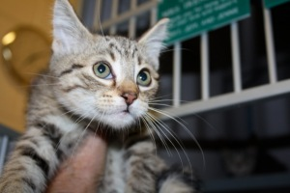 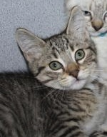**

1. **Luca** (ID:13228977): **Domestic Shorthair (DSH)/Mix**, neutered male, 2 months

**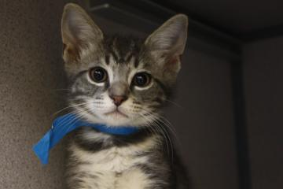 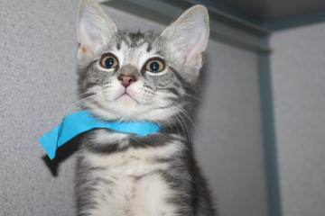 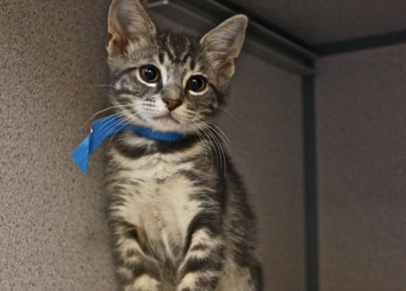**

1. **Pepper**: (ID: 13163414): **DSH**, spayed female, 2 months

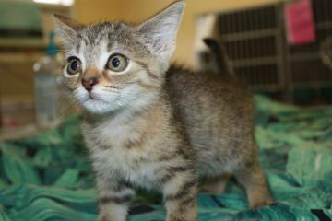 **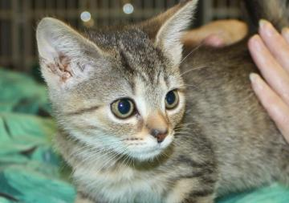**

**C.A.T.S. Bridge To Rescue (**www.catsbridge.org), 3415 Richlieu Road, Bensalem, PA 19020

* Contact Info: 215-987-8961; [Sandyquilt36@yahoo.com](mailto:%20sandyquilt36@yahoo.comt)
* Adoption fee (**$125**): include routine shots, litter trained, spaying/neutering

1. **Baby girl: Russian Blue/Tabby Mix**, female, 5 wks,
   1. After much attention Baby girl and her sisters made a wonderful recovery and are doing fantastic. They have been weaned from the bottle and are eating on their own as well as using a litter pan. These babies have been hand raised which makes them extremely loving, they enjoy being held and pet as much as you are willing to do it. You can pre-adopt at this time and they will be ready to leave foster on July 17th.

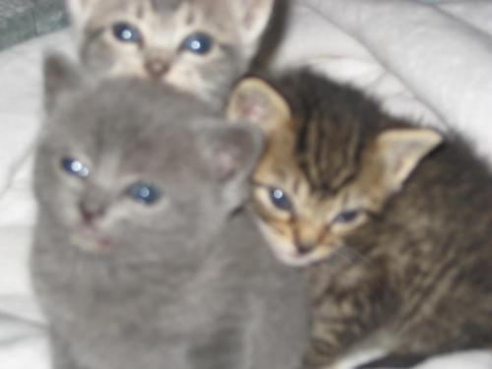 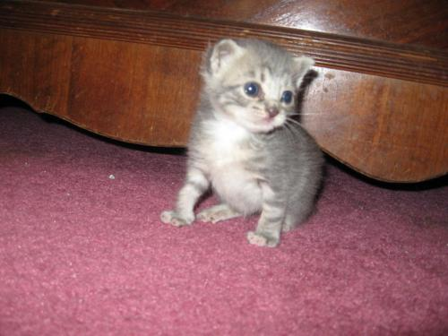

1. **Pewter: DSH-Grey/White,** male, 8wks
   1. He and siblings have since become some of my favorite kittens, they are playful, loving and good natured.

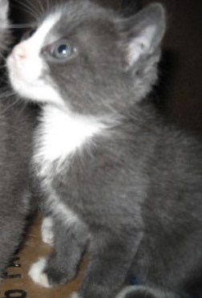 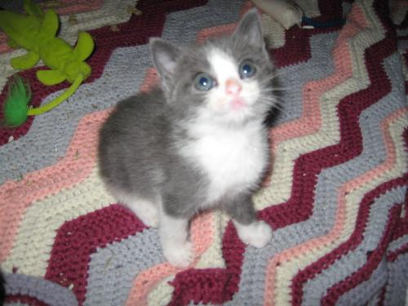

**Whiskers in Waiting (**[http://www.petfinder.com/shelters/NJ539.html](http://www.petfinder.com/shelters/NJ539.html" \t "_blank))**:** Woodbridge, NJ07095

* Most of the cats on this page are not local. They are either in one of our out of state foster homes or still in the high kill shelter with very little time left. NEED TO ACT QUICKLY. Contact by email if see one you like. We will transport it to Woodbridge, NJ from the shelter or foster home.
* Contact info: [waitingwhiskers@aol.com](mailto:waitingwhiskers@aol.com)

\*\*7/4: emailed request for info @ the kittens (asked for quick response)

1. **Smokey: Russian Blue/Maine Coon,** male,routine shots • House trained🡪 **“**Just arrived- little scared, but coming around quickly. Beyond gorgeous.”http://www.petadoptiontracker.org/pet?3520338&a=4621&h=

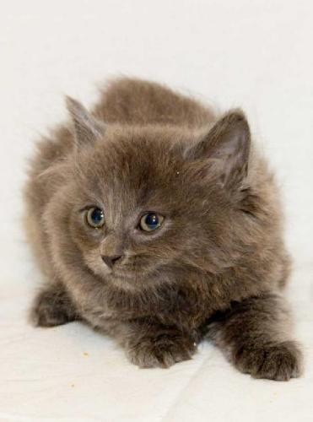

1. **Danny: Maine Coon,** male, routine shots • House trained

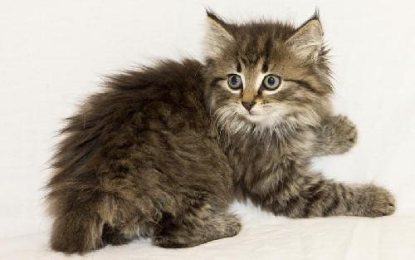

1. **Nicky: Russian Blue/Mix,** male, routine shots • House trained

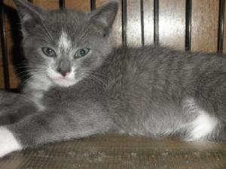

1. **Becca: Russian Blue Mix**, female kitten, routine shots, house trained

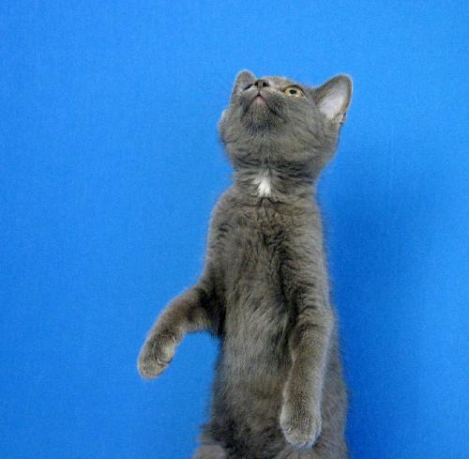 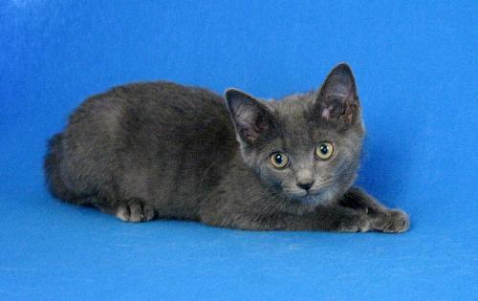 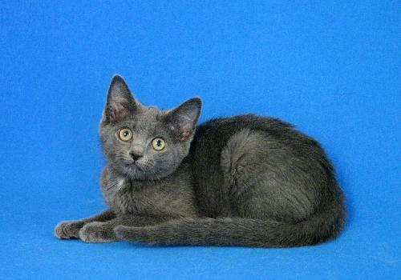

# Steven and Tyler: Extra-Toes Cat (Hemingway Polydactyl)/Bengal Mix, young? males, routine shots, litter trained

* 1. They look like a mix of Savannah and tried real hard to be Polydactyl (as you can see by the paws of Steven in the center).  The 2 boys on the right are available: they are beautiful and very close with each other.

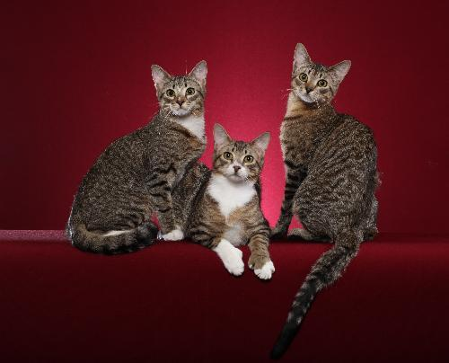

1. Cinder: Russian Blue mix, female kitten, routine shots, litter trained

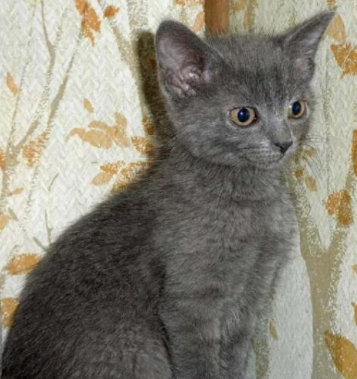

1. **Oreo: Maine Coon Mix,** male, routine shots • House trained

**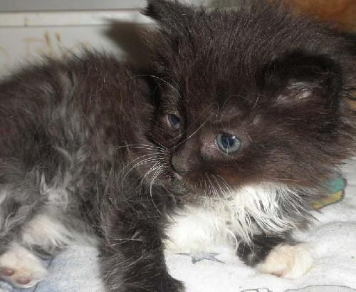**

1. **Snowie: Turkish Angora/Maine Coon, young female**, routine shots • House trained

**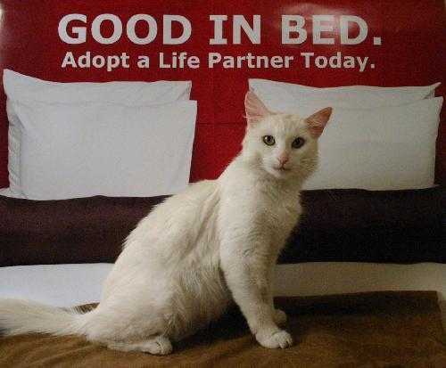**

1. **Button: Bobtail,** male, routine shots • House trained 🡪 “Button is so adorable and very sweet!http://www.petadoptiontracker.org/pet?3520169&a=4621&h=”

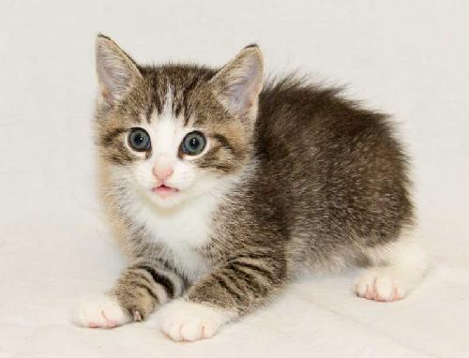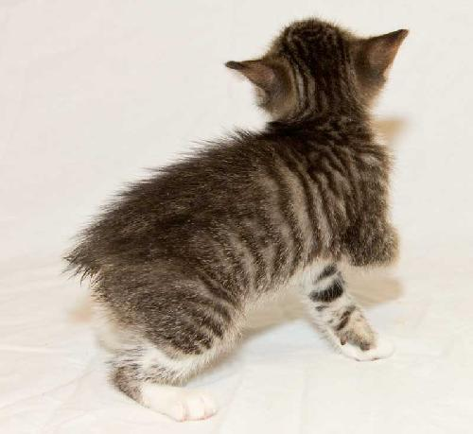

1. **Tommy: Turkish Van**, male, routine shots • House trained

**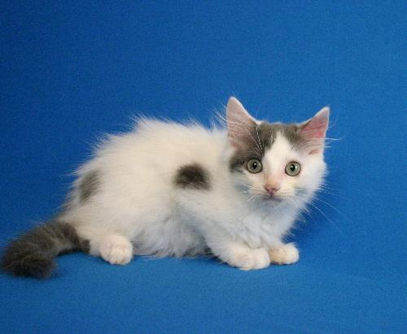**

**Cat Shack Rescue,** P.O. Box 950, Trexlertown, PA 18087-0950

1. Contact Info: 610-967-9097, [catshack@ptd.net](mailto:catshack@ptd.net)
2. The Cat Shack rescue is all volunteer and the adopted cats are delivered to your home
   1. Adoption fee: $85 covers medical expenses (routine FIV/FELV testing, deworming, all required vaccinations/ being fixed (as age permits)
   2. “Young KITTENS are always adopted in Pairs or to homes with other felines already in the home.”

\*\*Completed the online application 7/2 (as they request any potential applicant does)

1. **Snoopy: Russian Blue/ Domestic Short Hair Mix**, male

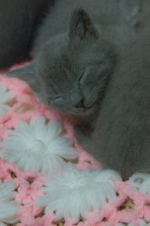 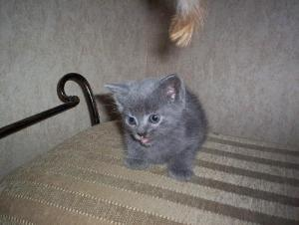

1. **Scooby (his brother): Russian Blue/ Domestic Short Hair Mix**, male

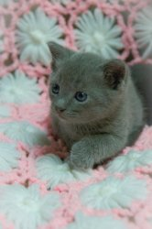 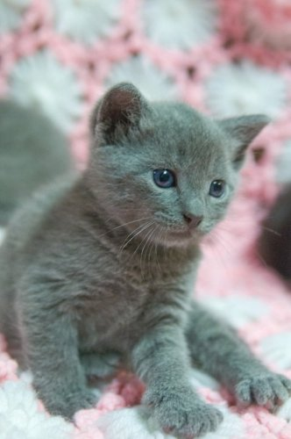

**New Beginnings Cat Adoption (**[www.newbeginningscatrescue.com](http://www.newbeginningscatrescue.com)): **network of foster families throughout New Jersey**

1. Contact Info: 908-914-2371; [kimbennett16@comcast.net](mailto:kimbennett16@comcast.net) (Director of Adoption)
2. Cats show at Pet Value: 1885 Rt. 57, Hackettstown, NJ 07840 every Sat/Sun from 12-4 pm or by appointment
3. Adoption fee is $125.00/cat and $175.00 for 2 which pays for:
   1. Temperament screening
   2. FIV/FeLV testing, deworming, clipped nails, and all required vaccinations/being fixed (as age permits)
   3. Microchipping may be included on some animals
4. **Cookie: Russian Blue**, male, 4 months

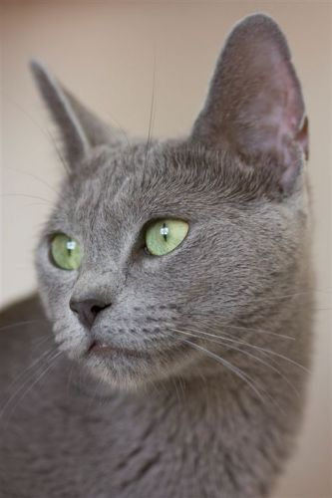

1. **CoCo (**sister to Cookie): **female black DSH Mix** (Russian Blue?), 4 months

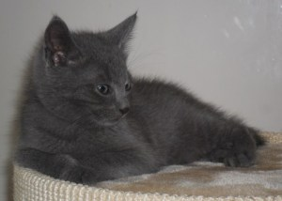

**Forgotten Cats (**<http://www.forgottencats.org/index.php>)**:** Mailing:4023 Kennett Pike, Ste 422, Greenville, DE 19807

* Contact Info: PA #: 215-219-8148, Email: [info@forgottencats.org](mailto:info@forgottencats.org)
* All adoption cats have been fixed, dewormed, received rabies and distemper inoculations, and tested for FLK/ FIV
* Adoption Fees: $90.00 for cats under 7 years of age; $160.00 for 2 cats under 7 yo; $50.00 for cats 7+ yo

\*\*I completed an online applic 7/3 as I was instructed in an email by a staff member🡪 It is the first step of adoption

1. **Yuri**: **Russian Blue Mix**, neutered male
   1. He and his two siblings, YaYa and Yodel, are super sweet, social, and absolutely love people.
   2. Yuri has a cloudy eye that is permanent damage from an eye infection he had as a baby.
   3. I am currently at: PetSmart Adoption Center, 300 Water Loop Dr Collegeville, PA 19426 (610)489-8240

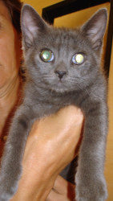

**Stray Cat Blues (**<http://www.petfinder.com/shelters/PA16.html>)**: PO Box 8, Colmar, PA 18915**

* Contact info: Phone: (215) 631-1851, Email: [savingstrays@yahoo.com](mailto:savingstrays@yahoo.com)
* **Adoption fee: $85**
* **Adopted kittens are fixed, litterbox trained, received age-appropriate vaccinations, and tested for FeLV/FIV**
* Primary adoption efforts are focused in Montgomery and Bucks counties, but we will, on a case-by-case basis, make placements in other local counties.

\*\*completed initial application (have to if want to even inquire about the cats) on 7/3/11

1. **Myron (**Pet ID: 6475 MB): **Russian Blue Mix**, neutered male, approx. 3 mos

* Myron is a fantastic kitten that would do well in a variety of home settings. He is microchipped.

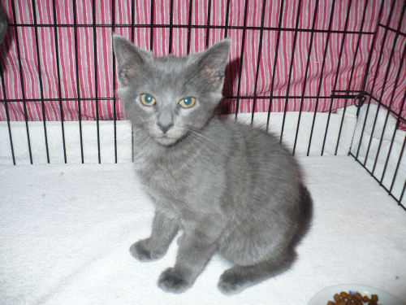 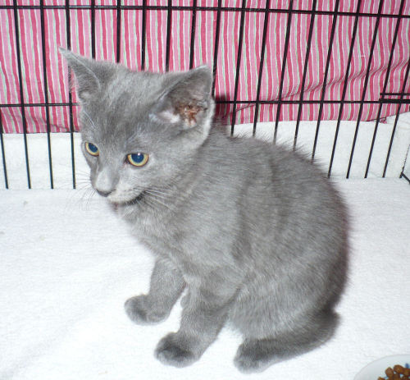

**Last Chance Ranch Animal Rescue (**<http://www.lastchanceranch.org/>): 9 Beck Rd,Quakertown, PA, 18951

* Contact Info: Phone: 215-538-2510; Email: [pets@lastchanceranch.org](mailto:pets@lastchanceranch.org)
* Everyone must follow adoption procedures: 1) application, 2) reference checks, 3) visit, 4) adoption.
* Adoption fee is typically $100

\*\*I completed the online application 7/4 in order to get ball rolling, get a visit, and determine interest.

1. **Google** (Pet ID: 13331107): **Bengal/DSH Mix**, neutered male kitten (age??)

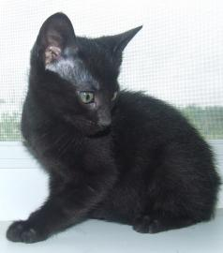

OR (not at this shelter…)

1.5 yo female, “small”, “sociable”, “quiet” greyhound :}

